Hershey and Chase set out to determine what molecule served as the unit of inheritance. Which molecular component of the T2 virus actually ended up inside the cell?
A. The protein coat
B. RNA
C. Ribosome
D. DNA
ANSWER: D
Choose the incorrect statement about the results of the Hershey-Chase Experiment
A. Radioactive labeled protein was found in the bacteria
B. Radioactive labeled DNA was found in the bacteria
C. DNA was labeled with radioactive phosphorus
D. Protein was labeled with radioactive sulfur
ANSWER: A
According to this model, the two parental DNA strands separate and each of these strands then serves as a template for the synthesis of a new DNA strand. The result is two DNA double helices, both of which consist of one parental and one new strand
A. conservative
B. semi-conservative
C. dispersive
D. none of these
ANSWER: B
This model states that after replication has occurred one daughter molecule contains both parental DNA strands, and the other daughter molecule contains DNA strands of all newly-synthesized material.
A. conservative
B. semi-conservative
C. dispersive
D. none of these
ANSWER: A
This model explains that during DNA replication, the parental DNA molecule is dispersed into its nucleotide, then these nucleotide combine together with new nucleotide to form two new daughter DNA molecules.
A. conservative
B. semi-conservative
C. dispersive
D. none of these
ANSWER: C
There were _____ models suggested for DNA replication
A. 5
B. 2
C. 3
D. 4
ANSWER: C
Model(s) suggested for DNA replication include:

A. conservative
B. semi-conservative
C. dispersive
D. All of these
ANSWER: D
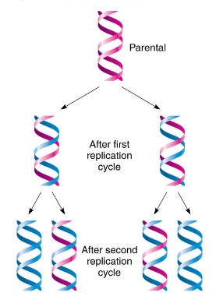
The diagram shows ______ model of DNA replication
A. conservative
B. semi-conservative
C. dispersive
D. none of these
ANSWER: B
Which of the following facts did Hershey and Chase make use of in trying to determine whether DNA or protein is the genetic material?
A. DNA contains sulfur, whereas protein does not
B. DNA contains phosphorus, whereas protein does not
C. DNA contains nitrogen, whereas protein does not
D. DNA contains purines, whereas protein includes pyrimidines
ANSWER: B
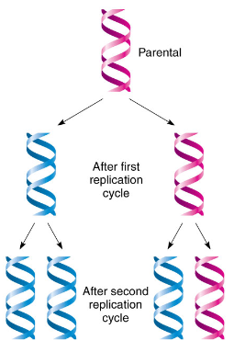
The diagram shows ______ model of DNA replication
A. conservative
B. semi-conservative
C. dispersive
D. none of these
ANSWER: A
The final proof for DNA as the genetic material came from the experiments of :
A. Griffith
B. Hershey and Chase
C. Avery, Mcleod and McCarty
D. Hargobind Khorana
ANSWER: B
Bacteriophages are
A. Viruses
B. Bacteria
C. Prions
D. Viroids
ANSWER: A
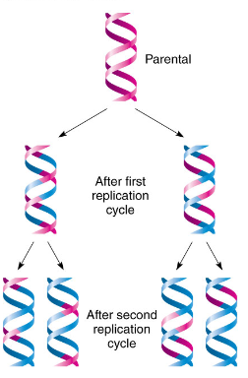
The diagram shows ______ model of DNA replication
A. conservative
B. semi-conservative
C. dispersive
D. none of these
ANSWER: C
The experiment done by _______ demonstrated that DNA replicated semi-conservatively
A. Darwin
B. Mendel
C. Meselson and Stahl
D. Pasture
ANSWER: C
The process of self synthesis of DNA molecule is called:
A. DNA replication
B. protein replication
C. RNA replication
D. None of these
ANSWER: A

